The Write Stuff!!! Week #1
____________________________________________________________________________
Monday—Write down five errors you see in the story you see on the board.
1.____________ 2.____________ 3.____________

4.____________ 5.____________

Tuesday—Summarize your summer in one sentence.
____________________________________________________________________________
Summarize your first week of school in one sentence.
____________________________________________________________________________
Wednesday—Label the following sentences “C” for complete, “F” for fragment, or “R” for run-on. Fix the run-on on the lines below.
1.___ The first week of school was exciting interesting terrific.
2.___ Mr. Martin gave us an assignment on the first day of class!
3.___ Can’t wait for the rest of the year!
____________________________________________________________________________
Thursday—Use your thesaurus to re-write the following sentence with more descriptive words.
Wow! This problem is extremely difficult and confusing!

____________________________________________________________________________
Friday—Write the three hardest words on your spelling list in sentences.
1.__________________________________________________________________________________
2.__________________________________________________________________________________
3.__________________________________________________________________________________

The Write Stuff!!! Week #2
____________________________________________________________________________
Monday—Write down five errors you see in the story you see on the board.
1.____________ 2.____________ 3.____________

4.____________ 5.____________
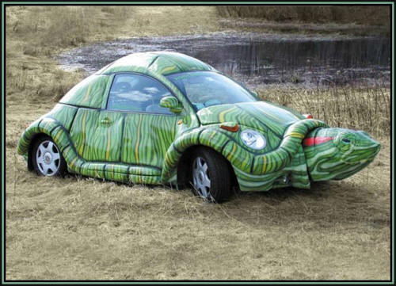
Tuesday—Whose car is this, and where has it been? What was the biggest adventure its driver ever had?

_______________________________________________________
_______________________________________________________
_______________________________________________________
_______________________________________________________
____________________________________________________________________________Wednesday—Label the following sentences “C” for complete, “F” for fragment, or “R” for run-on. Fix the fragment on the lines below.
1.___ Find me a calculator get a ruler and a protractor.
2.___ This math problem on page 77.
3.___ Ask the teacher if she can explain how to do this.
___________________________________________________________________________________
Thursday—Use your thesaurus to re-write the following sentence with more descriptive words.
Does my dumb little brother bother me? Yes, he makes me so mad.

____________________________________________________________________________
Friday—Write the three hardest words on your spelling list in sentences.
1.__________________________________________________________________________________
2.__________________________________________________________________________________
3.__________________________________________________________________________________

The Write Stuff!!! Week #3
____________________________________________________________________________
Monday—Write down five errors you see in the story you see on the board.
1.____________ 2.____________ 3.____________

4.____________ 5.____________
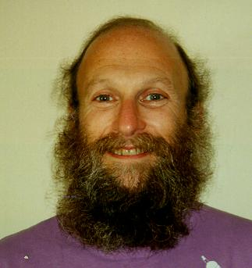
Tuesday—What is this person’s name? What did he do to get kicked out of his family?
______________________________________________________________________
______________________________________________________________________
____________________________________________________________
____________________________________________________________
____________________________________________________________
Wednesday—Label the following sentences “C” for complete, “F” for fragment, or “R” for run-on. Fix the fragment on the lines below.
1.___ Catfish in the stream.
2.___ The sun peeks over the hills the dusk begins to disappear.
3.___ Birds chirp merrily in the brush, announcing a new day.
______________________________________________________________________________________________________________________________________________________________________
Thursday—Use your thesaurus to re-write the following sentence with more descriptive words.
The odd boy, the one with the messy appearance, was made fun of by the mean kids.
____________________________________________________________________________
____________________________________________________________________________
Friday—Write the three hardest words on your spelling list three times each.
1.___________________________________________________________________________
2.___________________________________________________________________________
3.___________________________________________________________________________

The Write Stuff!!! Week #4
____________________________________________________________________________
Monday—Write down five errors you see in the story you see on the board.
1.____________ 2.____________ 3.____________

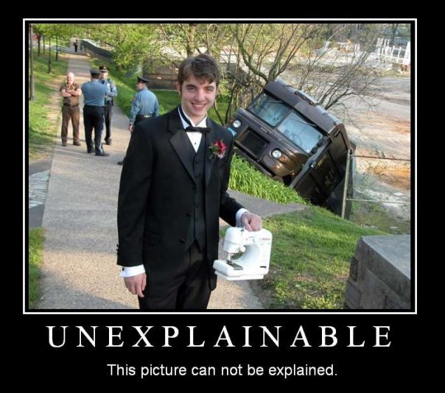
4.____________ 5.____________
Tuesday—Explain what happened in this “unexplainable” picture.
_______________________________________________________________
_____________________________________________________________
_____________________________________________________________
_____________________________________________________________
_________________________________________________________________Wednesday—
Label the following sentences “C” for complete, “F” for fragment, or “R” for run-on. Fix the run-on on the lines below.
1.___ Ted studied.
2.___ Flipped through the pages looking for bold-faced words.
3.___ The test will be difficult it is one hundred items long.
___________________________________________________________________________________
___________________________________________________________________________________
Thursday—
Use your thesaurus to re-write the following sentence with more descriptive words.
Starving, the quick, hungry lion fought the big elephant and killed it.
____________________________________________________________________________
____________________________________________________________________________
Friday—
Write the three hardest words on your spelling list three times each.
1.___________________________________________________________________________
2.___________________________________________________________________________
3.____________________________________________________________________

The Write Stuff!!! Week #5
____________________________________________________________________________
Monday—Write down five errors you see in the story you see on the board.
1.____________ 2.____________ 3.____________

4.____________ 5.____________
Tuesday—Combine the following sets of short choppy sentences into one complex sentence.
—The dolphin leaped through a hoop. —The hoop was plastic. —The dolphin was in the aquarium.
—The dolphin leaped gracefully. —The dolphin was gray.
___________________________________________________________________________________
___________________________________________________________________________________
Wednesday—Label the following sentences “C” for complete, “F” for fragment, or “R” for run-on. Fix the fragment on the lines below.
1.___ Frieda flipped the note to Fred he unfolded it.
2.___ “Do you want to be my boyfriend?” it asked.
3.___ Glanced over at Frieda and winked.
___________________________________________________________________________________
___________________________________________________________________________________
Thursday—Use your thesaurus to re-write the following sentence with more descriptive words.
Located in the museum, the old printing device has a lot of complex features.
____________________________________________________________________________
____________________________________________________________________________
Friday—Write the three hardest words on your spelling list in sentences.
1.__________________________________________________________________________________
2.__________________________________________________________________________________
3.__________________________________________________________________________________

The Write Stuff!!! Week #6
____________________________________________________________________________
Monday—Write down five errors you see in the story you see on the board.
1.____________ 2.____________ 3.____________

4.____________ 5.____________
Tuesday—Combine the following sets of short choppy sentences into one complex sentence.
—My turtle raced. —It was the turtle with a purple helmet. —The turtle was on a Harley.
—He raced across the road. —He raced this afternoon. —The turtle was green.
—The road was dusty.
___________________________________________________________________________________
___________________________________________________________________________________
___________________________________________________________________________________
Wednesday—Label the following sentences “C” for complete, “F” for fragment, or “R” for run-on. Fix the fragment on the lines below.
1.___ Order two Big Macs and a large Coke.
2.___ Drove to the second drive-thru window.
3.___ They messed up there’s two double cheeseburgers instead.
__________________________________________________________________________________
__________________________________________________________________________________
Thursday—Use your thesaurus to re-write the following sentence with more descriptive words.
The crazy girl ran across the dangerously busy street, let out a loud shriek, and destroyed the garbage can.
___________________________________________________________________________
___________________________________________________________________________
Friday—Write the three hardest words on your spelling list in sentences.
1._________________________________________________________________________________
2.________________________________________________________________________________
3.________________________________________________________________________________

The Write Stuff!!! Week #7
____________________________________________________________________________
Monday—Write down five errors you see in the story you see on the board.
1.____________ 2.____________ 3.____________

4.____________ 5.____________
Tuesday—Combine the following sets of short choppy sentences into one complex sentence.
—Squawking parrots add their voices to a loud chorus.
—Scurrying monkeys add their voices to a loud chorus.
—Chirping insects add their voices to a loud chorus.
___________________________________________________________________________________
___________________________________________________________________________________
___________________________________________________________________________________
Wednesday—Write one incredibly poetic, descriptive sentence about the picture below.
_________________________________________________________
_________________________________________________________
_________________________________________________________
Thursday—Use your thesaurus to re-write the following sentence with more descriptive words.
The paintings and sculptures were beautiful, fancy, and interesting.
____________________________________________________________________________
____________________________________________________________________________
Friday—Chose three words from your spelling list and use them together in one sentence.
___________________________________________________________________________________
___________________________________________________________________________________

The Write Stuff!!! Week #8
____________________________________________________________________________
Monday—Write down five errors you see in the story you see on the board.
1.____________ 2.____________ 3.____________

4.____________ 5.____________
Tuesday—Combine the following sets of short choppy sentences into two more complex sentences.
1.The South American Amazon basin 2. The Amazon River is mighty.
It covers an area as large as the US. It begins in the Andes Mountains.
It is home to rain forests. The Andes are in Peru.
The forests are spectacular.
1.__________________________________________________________________________________
___________________________________________________________________________________
2.__________________________________________________________________________________
___________________________________________________________________________________
Wednesday—Write one incredibly poetic, descriptive sentence about the picture below.
_____________________________________________________________
_____________________________________________________________
_____________________________________________________________
_____________________________________________________________
Thursday—Use your thesaurus to re-write the following sentence with more descriptive words.
It was important that the student do the assignment, but he was lazy and didn’t show much effort.
____________________________________________________________________________
____________________________________________________________________________
Friday—Chose three words from your spelling list and use them together in one sentence.
___________________________________________________________________________________
___________________________________________________________________________________

The Write Stuff!!! Week #9
____________________________________________________________________________Monday—Which word in each pair below has the more positive connotation? Circle your answer.
1)Thrifty or penny-pinching 2)Pushy or aggressive 3)Politician or statesman
4)Chef or cook 5)Slender or skinny
Tuesday—Combine each set of short choppy sentences into one sentence. You may replace or change words. 1. Monkeys live high in the tree tops. 2. Rope-like climbing plants are called lianas.
Birds live high in the tree tops. They struggle upward to the canopy.
Insects live high in the tree tops. There, they get sunlight.
The tree tops are called canopies.
1.__________________________________________________________________________________
___________________________________________________________________________________
2.__________________________________________________________________________________
___________________________________________________________________________________
Wednesday—Write one incredibly poetic, descriptive sentence about the picture below.
_____________________________________________________________
_____________________________________________________________
_____________________________________________________________
Thursday—Use your thesaurus to re-write the following sentence with more descriptive words.
It turns out my boss was neither bad and mean; he was actually nice and comforting.
____________________________________________________________________________
____________________________________________________________________________
Friday—Write the three most difficult-to-spell words from this week’s list forward once and backward once.
1._______________ / ________________ 2._______________ / ________________
3._______________ / ________________

The Write Stuff!!! Week #10
____________________________________________________________________________
Monday—
Read the following sentences. Annette was surprised. Annette was amazed. Annette was astonished.
1. Do the words “surprised,” “amazed,” and “astonished” have approximately the same denotation and connotation?
__________________________________________________________________________________________________________________________________________________________________________________________________________________
Tuesday—Combine each set of short choppy sentences into one sentence. You may replace or change words. 1. Trees shed their leaves continually. 2. Anacondas can grow up to 28 feet long.
A bed of wet debris builds up. They slither through the trees.
This debris is on the floor of the forest. They slither around the trees.

1._________________________________________________________________________________
_____________________________________________________________________

2._________________________________________________________________________________
___________________________________________________________________________________
Wednesday—Write one incredibly poetic, descriptive sentence about the picture below.
_____________________________________________________________
_____________________________________________________________
_____________________________________________________________

Thursday—Use your thesaurus to re-write the following sentence with more descriptive words.
Although Edna was nice and wanted to give money to the charity, she was poor.
____________________________________________________________________________
____________________________________________________________________________
Friday—Write the three most difficult-to-spell words from this week’s list forward once and backward once.

1._______________ / ________________ 2._______________ / ________________
3._______________ / ________________

The Write Stuff!!! Week #11
____________________________________________________________________________
Monday— Which connotation is more positive? Circle your answer.
1. Our trip to the amusement park was _____. 3. Everyone had a _____ on his or her face on the way home.
a) fine a) smile
b) wonderful b) smirk
2. _______ people rode on the roller coaster. 4. We saw _____ animals in the animal house.
a) fascinating a) brave
b) weird b) foolhardy
Tuesday—Combine each set of short choppy sentences into one sentence. You may replace or change words. 1. Evan ate all the cheese fries. 2. Miles Davis skipped his trumpet classes.
He said he felt sick. He listened to Dizzy and Bird at the jazz club.
I called his mom. His parents had no idea.

1.__________________________________________________________________________________

___________________________________________________________________________________

2.__________________________________________________________________________________

___________________________________________________________________________________
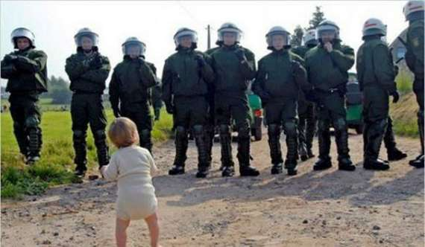
Wednesday—
Write a news caption to the picture below.
_____________________________________________ _____________
__________________________________________________________
__________________________________________________________
Thursday—Use your thesaurus to re-write the following sentence with more descriptive words.
Smart and full of effort, the scientist began making the complex machine.
____________________________________________________________________________
____________________________________________________________________________
Friday—Write the three hardest words on your spelling list in sentences.
1.__________________________________________________________________________________
2. ._________________________________________________________________________________
3..__________________________________________________________________________________

The Write Stuff!!! Week #12
____________________________________________________________________________
Monday— Which connotation is more negative? Circle your answer.
1. We bought _____ souvenirs at the amusement park. 3. Mike _____ us to go to his house.
a) cheap a) nagged
b) inexpensive b) reminded

2. I didn't like the _____ on the clown's face. 4. It made me feel _____.
a) frown a) uneasy
b) scowl b) frightened
Tuesday—Combine each set of short choppy sentences into one sentence. You may replace or change words. 1. You can have your cake and eat it too. 2. Abe Lincoln won a couple elections.
Your friends might be mad. He lost most of his elections.
You should have shared. He kept running for office.

1._________________________________________________________________________________

__________________________________________________________________________________

2._________________________________________________________________________________

__________________________________________________________________________________

Wednesday—Write a news caption to the picture below.
_________________________________________________________
_________________________________________________________
_________________________________________________________
Thursday—Use your thesaurus to re-write the following sentence with more descriptive words.
Putting off, Simon finally did the boring, difficult assignment that he hated.
____________________________________________________________________________
____________________________________________________________________________
Friday—Write the three hardest words on your spelling list in sentences.
1.__________________________________________________________________________________
2. ._________________________________________________________________________________
3..__________________________________________________________________________________

The Write Stuff!!! Week #13
____________________________________________________________________________
Monday—Rewrite the following sentence, giving the underlined words a more positive connotation while maintaining the same basic denotation.
It was a hot day. The sun was shining and the insects were humming. He located the tracks and began to follow them.

________________________________________________________________________________________________________________________________________________________
Tuesday—Combine each set of short choppy sentences into one sentence. You may replace or change words. 1. Teddy Grahams now comes in a new flavor. 2. Jimmy has six toes.
The new flavor is exciting. Jimmy just moved here.
The flavor is “Caramel Cutie.” The kids all call him “Webby.”

1.__________________________________________________________________________________

___________________________________________________________________________________

2.__________________________________________________________________________________

___________________________________________________________________________________
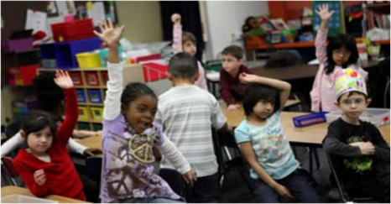
Wednesday—Write a news caption to the picture below.
___________________________________________________________
___________________________________________________________
_______________________________________________________________
Thursday—Use your thesaurus to re-write the following sentence with more descriptive words.
Moving happily, the doe basked in the bright, beautiful sunshine.
____________________________________________________________________________
____________________________________________________________________________
Friday—Write the three most difficult-to-spell words from this week’s list forward once and backward once.
1._______________ / ________________ 2._______________ / ________________
3._______________ / ________________

The Write Stuff!!! Week #14
Monday—Read the following passage and circle the words with the most negative connotation.
You can't go anywhere today without running into someone using a cell phone. People are either talking on them or texting. Okay, so we know the handheld devices are helpful tools, but shouldn't there be some rules about their use in society? Just because someone has a cell phone, does that make it okay to talk rowdily on it in public? Does everyone in the vicinity have to be bombarded with one-sided conversations, even if they don't want to?

Tuesday—Combine each set of short choppy sentences into one sentence. You may replace or change words. 1. My dad gave me a piece of advice once. 2. My mom threw a brick at us.
He said, “There are a lot of jerks in the world.” She got mad at Debbie and me.
He said I “better get used to it.” We didn’t clean up the toy room.

1.__________________________________________________________________________________

___________________________________________________________________________________

2.__________________________________________________________________________________

___________________________________________________________________________________
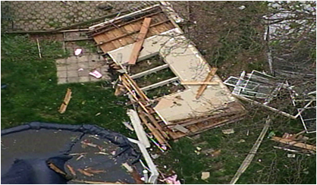
Wednesday—Write a news caption to the picture below.
_____________________________________________________ __
_________________________________________________________
_______________________________________________________________
Thursday—Use your thesaurus to re-write the following sentence with more descriptive words.
In contrast, I tried to help the victims at the scene of the gross, bad accident.
____________________________________________________________________________
____________________________________________________________________________
Friday—Write the three most difficult-to-spell words from this week’s list forward once and backward once.
1._______________ / ________________ 2._______________ / ________________
3._______________ / ________________

The Write Stuff!!! Week #15 ____________________________________________________________________________
Monday—Circle the word in the following passage that doesn’t fit because its connotation doesn’t match that of the rest of the paragraph? What word would appropriately replace it?
As a child, they say Mary Walker was a bit of a brat. She always wanted to do things differently. When she grew up, she continued to do so, becoming the first woman military doctor, a prisoner of war, a spy, and the only woman to win the Medal of Honor, America's highest military award. Replacement word:______________________
Tuesday—Combine each set of short choppy sentences into one sentence. You may replace or change words. 1. The zombies smell awful. 2. Crazy Carl escaped from the asylum.
You can only kill them one way. He showed up at Nana’s quilting club.
You must hit them in the head. He apologized.
You must hit them with a blunt object. He was sorry about sending them threatening letters.

1.__________________________________________________________________________________

___________________________________________________________________________________

2.__________________________________________________________________________________

___________________________________________________________________________________Wednesday--Combine the sentences below so that they use fewer unnecessary words. Avoid omitting any important details.
Billy ate the old cheese. It stunk, but Billy ate it anyway. It was also warm. Well, Billy got sick. In fact, Billy had to go to the hospital for an entire week. (33)

___________________________________________________________________________________

___________________________________________________________________________________

___________________________________________________________________________________
Thursday—Use your thesaurus to re-write the following sentence with more descriptive words.
Due to his bad performance at the audition, his hopes of getting the singing job decreased.
____________________________________________________________________________
____________________________________________________________________________
Friday—Choose three words from your spelling list and use them together in one sentence.
___________________________________________________________________________________
___________________________________________________________________________________

The Write Stuff!!! Week #16
____________________________________________________________________________
Monday—Circle the adjective in the following passage doesn’t fit its formal tone. Provide a replacement word or phrase.

Born in 1832, Mary Walker graduated from medical school at the age of 21. She was the only female in her class and only the second U.S. woman to graduate from a medical school. When the Civil War broke out, she went to Washington, D.C. to become an Army surgeon. The Army gave her a tough time, so she volunteered as a nurse and went off to treat wounded soldiers. Replacement word:______________________
Tuesday—Combine each set of short choppy sentences into one sentence. You may replace or change words. 1. It was unfortunate when it happened. 2. The mechanic called.
We had our first snow day of the year. The mechanic is from Otto’s Autoshop.
It was the day we were to have He said your car is ready to be picked up.
played our rival, Fieldcrest. His name is Vinny.

1.__________________________________________________________________________________

___________________________________________________________________________________

2.__________________________________________________________________________________

___________________________________________________________________________________
Wednesday—Combine the sentences below so that they use fewer unnecessary words. Avoid omitting any important details.
The rain came down very, very heavy. The flooding rain overflowed the streets. I could see the yellow car lights reflect off all the water on the streets. (28)
___________________________________________________________________________________

___________________________________________________________________________________

___________________________________________________________________________________
Thursday—Use your thesaurus to re-write the following sentence with more descriptive words.
Furthermore, that man is false and only intends to destroy our peaceful community.
____________________________________________________________________________
____________________________________________________________________________
Friday—Choose three words from your spelling list and use them together in one sentence.
___________________________________________________________________________________
___________________________________________________________________________________

The Write Stuff!!! Week #17
____________________________________________________________________________
Monday—Circle the correct word.
1. (Weather/Whether) or not you like it, you’ll have to eat it. 2. The (weather/whether) is supposed to be stormy today.
3. If the (weather/whether) changes, maybe we can still play. 4. I don’t know (weather/whether) we’ll be able to play.
Tuesday—Combine each set of short choppy sentences into one sentence. You may replace or change words. 1. The bear toyed with the salmon. 2. Mr. Martin has three favorite albums.
The salmon was in the stream. They are by Bob Dylan. One is Blood on
The stream was cool. the Tracks. One is Highway 61 Revisited.
The bear was angry. One is John Wesley Harding.

1.__________________________________________________________________________________

___________________________________________________________________________________

2.__________________________________________________________________________________

___________________________________________________________________________________
Wednesday—
Write a simile, metaphor, or personification about the cold.

Write a simile, metaphor, or personification about the moon.

Thursday—Use your thesaurus to re-write the following sentence with more descriptive words.
At the buzzer, Sara made a great jump shot to stop the seemingly strong team’s winning streak.

____________________________________________________________________________
____________________________________________________________________________

Friday—Write two sentences below, each using one spelling word and this week’s sentence pattern.
1._____________________________________________________________________________________________________________________________________________________________________
2.__________________________________________________________________________________
___________________________________________________________________________________

The Write Stuff!!! Week #18
____________________________________________________________________________
Monday—Circle the correct word.
1. If you’d like to discuss this (Further/Farther), stay after class. 2. The (Further/Farther) you go up, the colder it’ll get.
3. If you go ten miles (Further/Farther), you’ll get to Iowa. 4. Is there anything (Further/Farther) you’d like to say?
Tuesday—Combine each set of short choppy sentences into one sentence. You may replace or change words. 1. Timmy and Tommy did it. 2. Susan was furious. She was red in the face.
They threw the snow balls. She said she would never eat at this restaurant again.
The snow balls hit the teacher. She yelled. It was loud.
The teacher fell. The teacher was Mr. Tony.

1.__________________________________________________________________________________

___________________________________________________________________________________

2.__________________________________________________________________________________

___________________________________________________________________________________
Wednesday—
Write a simile, metaphor, or personification about an ornery child.

Write a simile, metaphor, or personification about a fish.

Thursday—Use your thesaurus to re-write the following sentence with more descriptive words.
To comfort the sad little dog, I hid the scary vacuum.

____________________________________________________________________________
____________________________________________________________________________
Friday—Write two sentences below, each using one spelling word and this week’s sentence pattern.
1._____________________________________________________________________________________________________________________________________________________________________
2.__________________________________________________________________________________
___________________________________________________________________________________

The Write Stuff!!! Week #19
____________________________________________________________________________
Monday—Circle the correct word.
1. As I drove (Through/Threw) the tunnel, my radio went dead. 3. I (Through/Threw) my hands in the air and gave up.
2. Tom (Through/Threw) the ball right into Walt’s yard. 4. (Through/Threw) the fog, I could see a large ship coming.
Tuesday—Combine each set of short choppy sentences into one sentence. You may replace or change words. 1. Mr. Jenkies walks his dog. 2. The sailor was depressed. The sailor was alone.
He walks his dog every morning. He He dove off the back of the ship. He was never
does it at 7:30. He wears a woman’s seen again. It happened in the Arctic Ocean.
robe. The dog’s name is Toby.
1.__________________________________________________________________________________

___________________________________________________________________________________

2.__________________________________________________________________________________

___________________________________________________________________________________
Wednesday—Circle the correct word.
1. After I went to the store, I (than/then) went home. 2. Fixing a car is more difficult (than/then) fixing a bicycle.
3. I ate five more pieces of pizza (than/then) Emily. 4. You should (than/then) turn your homework into the basket.
Thursday—
Write a simile, metaphor, or personification about a sunset.

Write a simile, metaphor, or personification about a tree.

Friday—Write two sentences below, each using one spelling word and this week’s sentence pattern.
1._____________________________________________________________________________________________________________________________________________________________________
2.__________________________________________________________________________________
___________________________________________________________________________________

The Write Stuff!!! Week #20
____________________________________________________________________________
Monday—Circle the correct word.
1. Each (Breath/Breathe) you take could be your last. 2. The attic was so dusty that I could hardly (Breath/Breathe).
3. As the ride came to a halt, I could (Breath/Breathe) easier. 4. Her (Breath/Breathe) smelled of garlic and tuna.
Tuesday—Combine each set of short choppy sentences into one sentence. You may replace or change words. 1. The water was rising. It was freezing and 2. A girl screamed, “Bomb!” Everyone panicked
murky. There was a boat coming to save us. when she screamed. They headed for the exits.
Oprah was in the boat. She was with Dr. Phil. Many got stepped on. It was in a movie theater.

1.__________________________________________________________________________________

___________________________________________________________________________________

2.__________________________________________________________________________________

___________________________________________________________________________________
Wednesday—Write a sentence that uses a specific, descriptive color.
________________________________________________________________________________________________________________________________________________________
Thursday—
Write a simile or metaphor about a parent.

Write a simile, metaphor, or personification about anything (you choose).

Friday—Write two sentences below, each using one spelling word and this week’s sentence pattern.
1._____________________________________________________________________________________________________________________________________________________________________
2.__________________________________________________________________________________
___________________________________________________________________________________

The Write Stuff!!! Week #21
____________________________________________________________________________
Monday—For each series of words, mark “D” for the words’ denotation, “P” for the word with a positive connotation, and “N” for the word with a negative connotation.
1. Extravagance____ Generosity____ Giving much____ 2. A young age___ Youthful____ Immature____

3. Not having a care____ Irresponsible____ Carefree___ 4. Ask of someone___ Demand____ Request___
Tuesday—Combine each set of short choppy sentences into one sentence. You may replace or change words. 1. Becky was babysitting. She was with the 2. It was blustery weather. It was ten below
Bauer twins. It was late Thursday night. zero. He was locked out of his house. He
Someone left a phone message. It was frightening. froze to death. He was only wearing his speedo.

1.__________________________________________________________________________________

___________________________________________________________________________________

2.__________________________________________________________________________________

___________________________________________________________________________________
Wednesday—Write a sentence that uses a specific, descriptive color.
____________________________________________________________________________
____________________________________________________________________________
Thursday—Write a correctly punctuated exchange of dialogue between a cat and a mouse.

________________________________________________________________________________________________________________________________________________________
____________________________________________________________________________
____________________________________________________________________________
Friday—
Write the three hardest words on your spelling list three times each.
1.___________________________________________________________________________
2.___________________________________________________________________________
3.____________________________________________________________________

The Write Stuff!!! Week #22
____________________________________________________________________________
Monday—Write down five errors you see in the story you see on the board.
1.____________ 2.____________ 3.____________

4.____________ 5.____________
Tuesday—Combine each set of short choppy sentences into one sentence. You may replace or change words. 1. Alex was thinking. “It is unfair.” “It is 2. The pudding spilled. It was all over the inside
unbelievable.” He was thinking when the cops of his bag. It covered his books. It covered his
arrived. They came to search his home. pencils. The pudding was banana flavor.

1.__________________________________________________________________________________

___________________________________________________________________________________

2.__________________________________________________________________________________

___________________________________________________________________________________
Wednesday—Write a sentence that uses a specific, detailed noun (3 descriptors min.).
.
____________________________________________________________________________
Thursday—Write a correctly punctuated exchange of dialogue between a pop tart and a toaster.

________________________________________________________________________________________________________________________________________________________
____________________________________________________________________________
____________________________________________________________________________
Friday—
Write the three hardest words on your spelling list three times each.
1.___________________________________________________________________________
2.___________________________________________________________________________
3.____________________________________________________________________

The Write Stuff!!! Week #23
____________________________________________________________________________
Monday— For each series of words, mark “D” for the words’ denotation, “P” for the word with a positive connotation, and “N” for the word with a negative connotation.

1. Discuss with others___ Debate___ Argue___ 2. Brainwash___ Persuade___ To convince another ___

2. Isolation___ Privacy___ Having an opportunity to be alone___ 4. Delayed__ Not on time___ Tardy___
Tuesday—Combine each set of short choppy sentences into one sentence. You may replace or change words.
1. The girl of his dreams sat. She sat in the 2. The boy of her dreams was there. He leaned
corner of the cafeteria. She was slurping her soup. against the soda machine. He wore a black
She had a chocolate milk mustache. leather jacket. He was listening to his iPod.
1.__________________________________________________________________________________

___________________________________________________________________________________

2.__________________________________________________________________________________

___________________________________________________________________________________
Wednesday—Write a sentence that uses a specific, detailed noun (3 descriptors min.).
____________________________________________________________________________
____________________________________________________________________________
Thursday—Write a correctly punctuated exchange of dialogue between a wealthy, educated woman and a crotchety hillbilly grandpa.
________________________________________________________________________________________________________________________________________________________
____________________________________________________________________________
____________________________________________________________________________
Friday—Below, write three of this week’s spelling words and then write an antonym beside each word.
Spelling Word Antonym
1._________________ ___________________
2._________________ ___________________
3._________________ ___________________

The Write Stuff!!! Week #24
____________________________________________________________________________
Monday—Write down five errors you see in the story you see on the board.
1.____________ 2.____________ 3.____________

4.____________ 5.____________
Tuesday—Combine each set of short choppy sentences into one sentence. You may replace or change words. 1. There are a number of things I need 2. Winston Hersherton was born in 1783. He died
to pick up. I need pretzels. I need chips. in 1862. He started out as a poor farmer. He
I need plates. I need cups. I need denture cream. purchased a lot of land. He became very wealthy.
1.__________________________________________________________________________________

___________________________________________________________________________________

2.__________________________________________________________________________________

___________________________________________________________________________________
Wednesday—Write the correct word in the blank, Desert or Dessert.
1. And for _________, we have a scrumptious chocolate cake.
2. Wade crawled through the __________, wishing he had water.
3. Because I’m trying to lose weight, I’m skipping _________.
Thursday—Write a correctly punctuated exchange of dialogue between any two people (your choice).
________________________________________________________________________________________________________________________________________________________
____________________________________________________________________________
____________________________________________________________________________
Friday—Below, write three of this week’s spelling words and then write an antonym beside each word.
Spelling Word Antonym
1._________________ ___________________
2._________________ ___________________
3._________________ ___________________

The Write Stuff!!! Week #25
____________________________________________________________________________
Monday—Combine the sentences below so that they use fewer unnecessary words. Avoid omitting any important details. The pitcher whipped the ball to second base. The runner couldn’t get back by the time the ball got there. She got picked off for the third out of the inning. (31)
___________________________________________________________________________________

___________________________________________________________________________________

___________________________________________________________________________________
Tuesday—Combine each set of short choppy sentences into one sentence. You may replace or change words. 1. Kip is training. He wants to be a 2. Napoleon likes Deborah. Napoleon is
cage fighter. He starts training at dawn. a junior at Prescott High. He is too shy to
He stops training at dusk. ask her out.

1.__________________________________________________________________________________

___________________________________________________________________________________

2.__________________________________________________________________________________

___________________________________________________________________________________
Wednesday—Write the correct word in the blank, Advice or Advise.
1. I decide to ask my dad for some __________ about what to do.
2. He said he would __________ me to just go and apologize.
3. I told him his ___________ was awful.
Thursday—Use your thesaurus to re-write the following sentence with more descriptive words.
The high-spirited student council member said, “Let’s plan a dance that’s totally different.”
____________________________________________________________________________
____________________________________________________________________________
Friday—Below, write three of this week’s spelling words and then write an antonym beside each word.
Spelling Word Antonym
1._________________ ___________________
2._________________ ___________________
3._________________ ___________________

The Write Stuff!!! Week #26
____________________________________________________________________________
Monday—Combine the sentences below so that they use fewer unnecessary words. Avoid omitting any important details. Woah! What a very close race! Kasey had the lead in the last lap of the 1600 meter race. Trevor pulled ahead right at the end. Both were running really hard. Trevor barely won—by a nose.(37)

___________________________________________________________________________________

___________________________________________________________________________________

___________________________________________________________________________________
Tuesday—Write a correctly punctuated exchange of dialogue between a mayor and an angry citizen.
________________________________________________________________________________________________________________________________________________________
____________________________________________________________________________
____________________________________________________________________________
Wednesday—Write the correct word in the blank, Devise or Device.
1. Dr. Schpip went to his lab to _________ a strange new chemical.
2. The product he was hoping to _________ would allow him to fly.
3. It might eliminate the need for planes and any other flying _____.
Thursday—Use your thesaurus to re-write the following sentence with more descriptive words.
“I can’t understand,” my mom yelled, “why you stubbornly refuse to do your chores.”
____________________________________________________________________________
____________________________________________________________________________
Friday—Below, write three of this week’s spelling words and then write an antonym beside each word.
Spelling Word Antonym
1._________________ ___________________
2._________________ ___________________
3._________________ ___________________

The Write Stuff!!! Week #27
____________________________________________________________________________
Monday—For “A” and “B,” circle the word that best fits the sentence. Then write a sentence that uses
both commonly confused words in a sentence.
A. Sometimes it is hard to (accept/except) losing. B. I am all done with my homework (accept/except) math.
___________________________________________________________________________________

___________________________________________________________________________________
Tuesday—Combine the sentences below so that they use fewer unnecessary words. Avoid omitting any important details. “She is really quite crazy. Well, one time I asked to borrow a pencil. She screamed at me so loud. Yeah, so I don’t talk to her anymore.” (28)

___________________________________________________________________________________

___________________________________________________________________________________

___________________________________________________________________________________
Wednesday—Write the correct word in the blank, Affect or Effect.
1. He hoped his sprained ankle would not _________ his play.
2. One _________ of the new rule is that kids now hate school.
3. Her grandfather’s recent death has _________ed her greatly.
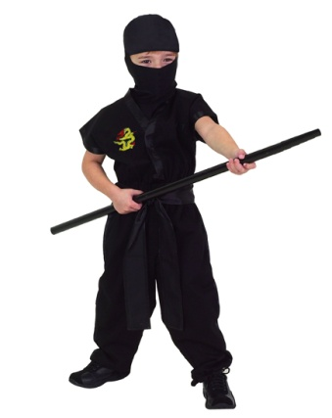
4. Spontaneous belching is one of the side ________s of this drug.
Thursday—Write one incredibly descriptive sentence about this kid ninja.

Friday—Below, write three of this week’s spelling words and then write an antonym beside each word.
Spelling Word Antonym
1._________________ ___________________
2._________________ ___________________
3._________________ ___________________

The Write Stuff!!! Week #28
____________________________________________________________________________
Monday—For “A” and “B,” circle the word that best fits the sentence. Then write a sentence that uses
both commonly confused words in a sentence.
- The chef has (all ready/already) prepared most of the food.
- The audience was (all ready/already) for the comedian to take the stage.
___________________________________________________________________________________
___________________________________________________________________________________
Tuesday—Combine the sentences below so that they use fewer unnecessary words. Avoid omitting any important details. “There were tons of butterflies all landing on the one bush. The bush was covered with tiny blue
wings. The wings of the butterflies made the bush look like it was alive.” (32)
___________________________________________________________________________________

___________________________________________________________________________________

___________________________________________________________________________________
Wednesday—Write the correct word in the blank, Site or Sight or Cite.
1. At the grave ________, the mourners said their final goodbyes.
2. The students all working hard on DOL was quite a _________.
3. The investigators had already shown up at the murder _______.
4. When you’re using information from a source in your paper, be sure to ________ where it came from.
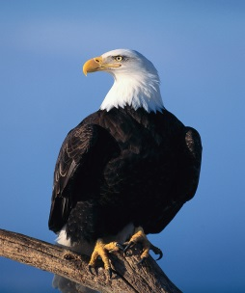
Thursday—Write one incredibly descriptive sentence about this eagle.

Friday—Below, write three of this week’s spelling words and then write an antonym beside each word.
Spelling Word Antonym
1._________________ ___________________
2._________________ ___________________
3._________________ ___________________

