Will Pearson
3rd Hour

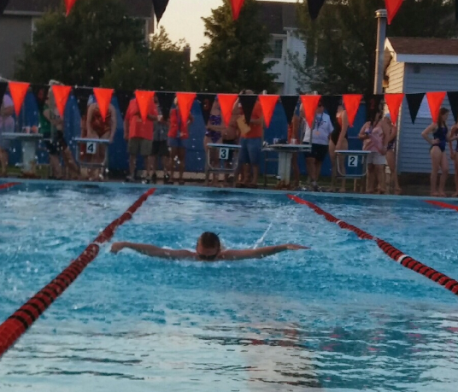
Picture in a Paragraph Essay

As I bounded off the starting block, a rush of adrenaline immediately passed through my body. I hit the water like a hawk diving hundreds of feet out of the sky to capture it’s prey. When I finally surface from the water, I instantly bolt through the vibrant turquoise water. I start to swim down my lane, gaining speed with every passing stroke. When get close to the wall, I can feel my heart racing with excitement and anticipation for the outcome of the race. I start to close in on the end of the pool and just as am about to smash into it, I successfully thrust off the wall, turn direction, and head the other way. While I am under the brisk pool water, I regain my concentration and surface from the water once more. I turn in the other direction and prepare myself for the final twenty-five. Now I have been drained of the energy I started with, and out of the corner of my eye I spot my opponent closing the gap I once had on him. With only ten yards left, I muster every ounce of energy I have left. When I come to the wall, I instantaneously look to my far right, not yet recognizing that I had narrowly escaped defeat against my opponent.I then lifted myself out of the water as a feeling of triumph passed through me.

